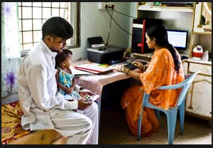

|  |  |
| --- | --- |
| User REFERENCE GUIDE  For Kiosk Banking Application at ICICI | Abstract  A complete guide for all users for using Kiosk Banking online solution at ICICI Kiosks.  STRIVE User Guide Version 1.0 |

Contents

1. Preface 3

1.1. Intended Audience 3

1.2. How this document is organized 3

2. Introduction 4

2.1. Product Description 4

3. System Requirements 5

3.1. Hardware Requirement 5

3.2. Software Requirement 5

3.3. Network Requirement 5

4. Login into Banking Application 6

5. Logout from Banking Application 9

6. Aadhaar Banking Services 10

6.1. Cash Deposit 10

6.2. Cash Withdrawal 15

6.3. Mini Statement 21

6.4. Balance Inquiry 26

7. Transaction History 31

8. Appendix 33

8.1. Important terms used in the document 33

8.2. Biometric Device setup 34

8.3. Install the driver for the device mfs100-sdk on your machine. 34

8.4. Edit the java policy in the system. Replace the ‘java.policy’ file in your system’s C:\Program Files (x86)\Java\jre1.8.0_25\lib\security’ folder with the file found with the mfs100 driver. 34

8.5. Restart the browser. The biometric device setup is complete. Connect the biometric device to your system via USB, and the device will be ready to use. 34

8.6. Best practices for finger scanning 35

8.7. Troubleshooting 35

1. Preface
   1. Intended Audience

This document is intended for Agent (Kiosk Operator) users, also known as VLE (Village Level Entrepreneur) who are business facilitators and operate *ICICI*’s Kiosks.

Agent(s) provide banking services such as Cash Deposit, Cash Withdrawal, Balance Inquiry, Mini-Statement.

* 1. How this document is organized

Entire product features are divided functionality-wise into individual chapters.

All the functionalities of the product are explained and steps to perform each function are clearly mentioned with screen snapshots and screen component details. List of functions covered is as below:

1. Login to application
2. Logout from application
3. Aadhaar Banking Services
4. Introduction
   1. Product Description

Financial Inclusion solution is a web based Kiosk Banking solution i.e FI Gateway.

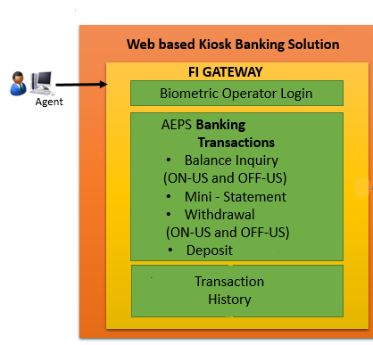

Figure 1: Financial Inclusion Solution

FI Gateway is a Biometric Authentication based kiosk banking solution that allows the user to perform various banking operations.

1. System Requirements

For using this application, please follow below minimum system requirement.

* 1. Hardware Requirement

1. Biometric device – *(any one)*
2. Morpho MSE 1300E
3. CPU and Monitor -
   1. Processor: i5
   2. RAM: 6 GB
   3. HDD: 250 GB
4. Printer -

Any printer has to be configured and connected to the system.

* 1. Software Requirement

1. Operating System -

Windows 7 or later must be installed and running on the systems.

1. Browser -
2. Internet Explorer version 10 must be used for using the system. OR
3. Mozilla Firefox latest version.

Popups must be enabled in the browser.

1. Java -

Java version 1.8 update 25 (or latest version)

* 1. Network Requirement

System must be connected to un-interrupted internet connection.

1. Login into Banking Application

User can login into the Banking application using its Agent ID, OTP and biometrics.

**To login into the Banking application**

1. Enter the provided URL of the application in the address bar of the browser. The system displays the login page of the Banking application.

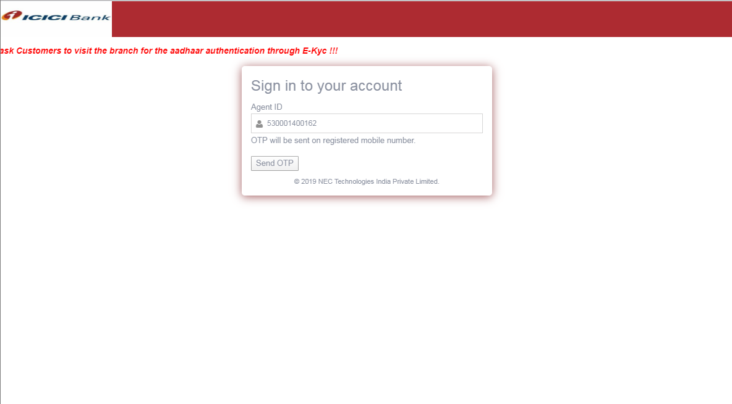

Figure : Login Screen

1. Enter your **Agent ID.** Click on Send OTP button**.**

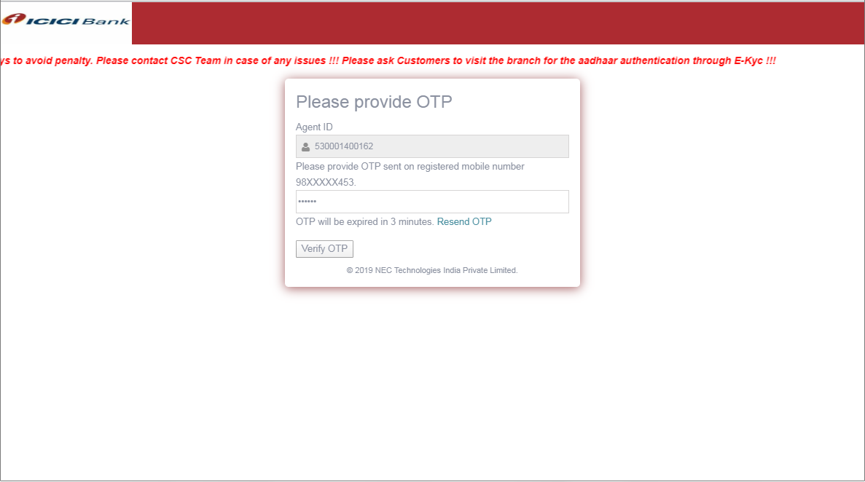

Figure 3: Banking Application Login screen with OTP

**Field Description**

* All (*) marked fields are mandatory

| Field Name | Field Type | Description |
| --- | --- | --- |
| Agent ID (*) | [Numeric, Max. Length – 12] | Type the Agent ID |
| OTP (*) | [Numeric, Length - 6] | Enter the OTP received on registered Mobile. |

1. OTP will be send on registered mobile number of agent. Enter the received OTP and Click on Verify OTP
2. Enter Aadhaar Number and Capture biometric of the Agent using Capture Button.

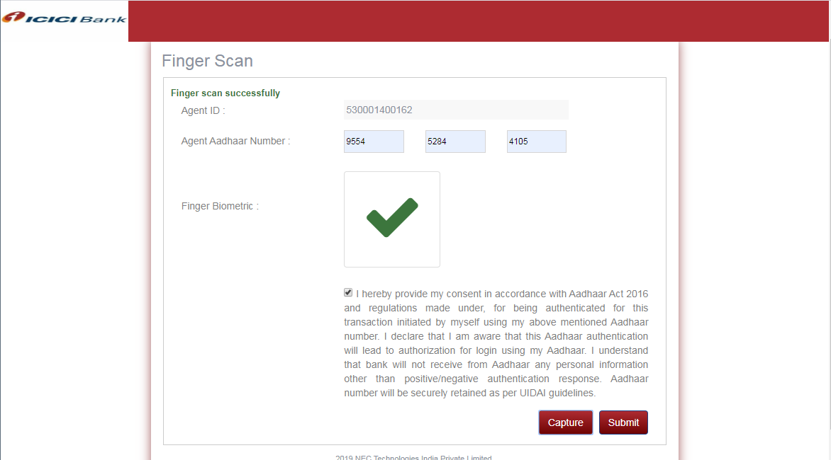

Figure 4: Agent Authentication in Banking Application

1. After Successful Capturing the Biometric a green tick will be displayed in Finger Biometric Box. Click on Submit.
2. The system displays the welcome screen in the banking application.

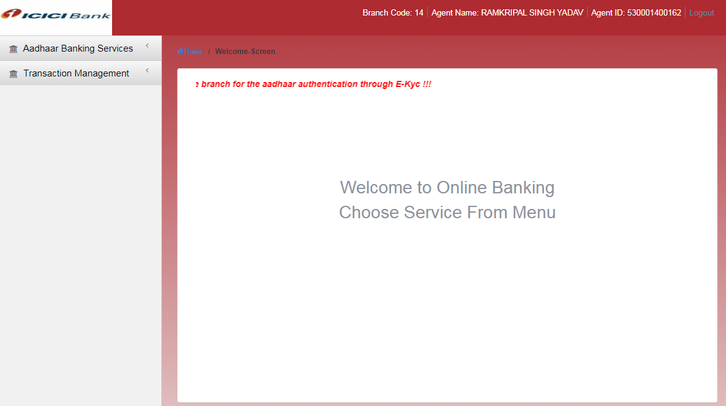

Figure 5: Welcome Screen on Login

1. Logout from Banking Application

This option allows you to log out of the Banking application.

**To log out of the Banking application**

1. Login into the Banking application.

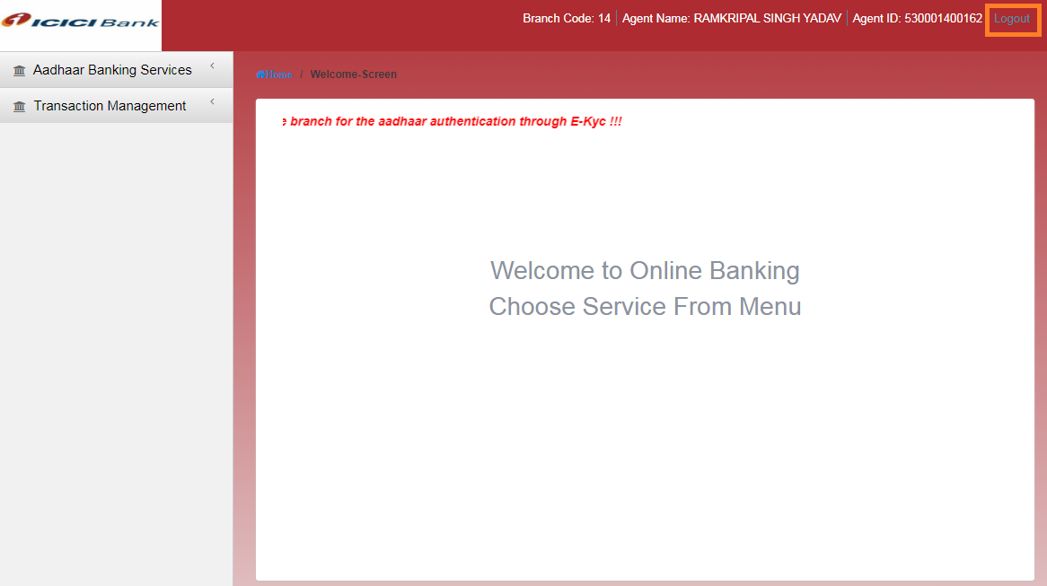

Figure 6: Logout link on the Banking Application screen

1. Click on the **Logout** button at the right hand corner of the Banking application screen. The system displays **Banking Application Login screen**.
2. Aadhaar Banking Services

This feature allows the Agent users to perform Aadhaar based Banking transactions for the customers.

* 1. Cash Deposit

This option allows the Agent user to perform cash deposit banking transaction for a customer.

To do a Cash Deposit transaction

1. Log on to the Banking Application as Agent user.
2. Navigate through the menus to **Aadhaar Banking Services -> Deposit**. The system displays Cash Deposit screen.

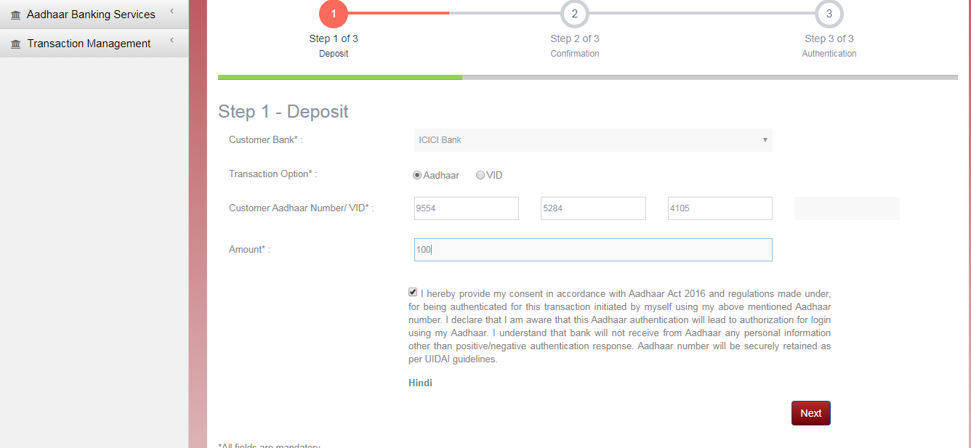

Figure 7: Step-1 Cash Deposit screen

**Field Description**

* All (*) marked fields are mandatory

| Field Name | Field Type | Description |
| --- | --- | --- |
| Customer Bank | [Drop Down] | Select from the list of Customer Banks. (ICICI auto selected as bank support only ON-US transaction) |
| Customer Aadhaar Number /VID (*) | **Aadhaar**: [Numeric, Min. Length - 12]  **VID**: Numeric, Min. Length - 16] | Enter the Aadhaar Number of the customer. This number must have 12 digits.  In case of VID This number must have 16 digits. |
| Amount (*) | [Numeric] | Enter the amount of the transaction. The data in this field accepts .50 and .00 in decimal places. |
| Next | [Button, Enabled] | Click this button to move to the next step of the transaction. |

1. Enter all the mandatory transaction data. Click on Next button. The system displays the Step-2 screen of the deposit transaction.

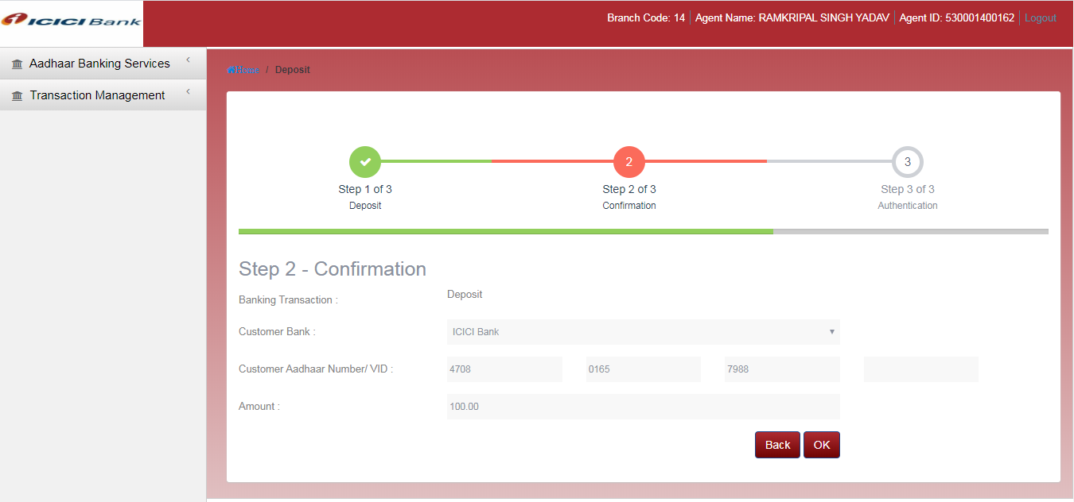

Figure 8: Step-2 Deposit transaction screen

**Field Description**

* All (*) marked fields are mandatory

| Field Name | Field Type | Description |
| --- | --- | --- |
| Banking Transaction | [Display] | This field displays the type of Banking Transaction |
| Customer Bank | [Display] | This field displays the Customer Bank name. |
| Customer Aadhaar Number/VID | [Display] | This field displays the Aadhaar Number/VID of the customer as entered in the Step-1. |
| Amount | [Display] | This field displays the amount of the transaction as entered in the Step-1. |

1. On the confirmation screen, verify that the transaction data is correct, as per transaction requirement.
2. Click on **OK** button to move to the next step of the transaction. The system displays the Step-3 screen of deposit transaction.

OR

To edit the data, click on **Back** button to move to the previous step of the transaction.

**Field Description**

* All (*) marked fields are mandatory

| Field Name | Field Type | Description |
| --- | --- | --- |
| Customer Aadhaar Number | [Display] | This field displays the Aadhaar Number of the customer as entered in the Step-1. |
| Hand | [Radio Button] | Select the hand of the customer, for which the biometric shall be provided. |
| Finger Position | [Radio Button] | Select the finger position of the customer, for which the biometric shall be provided. |
| Finger Biometric | [Picture] | Picture of the biometric scan. |

1. Place customer’s selected finger on the biometric device. Click on the **Start** button to begin biometric scan process. Image of the scan will appear in the finger Biometric area.

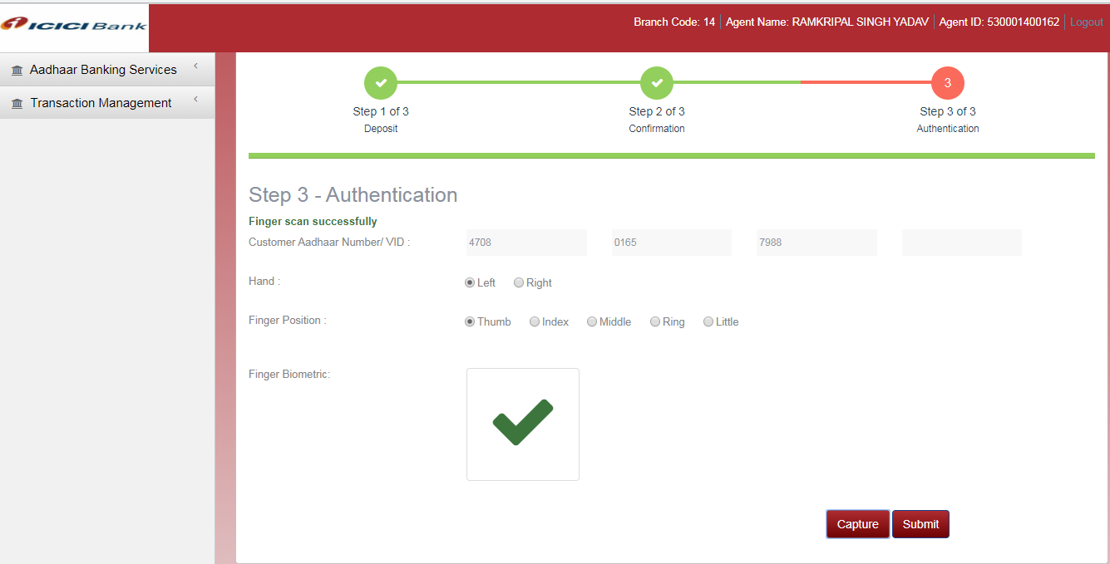

Figure 9: Step-3 Deposit transaction screen.

1. Click on the **Submit** button. The transaction is complete. The system will display the transaction status message and a transaction slip will be generated.

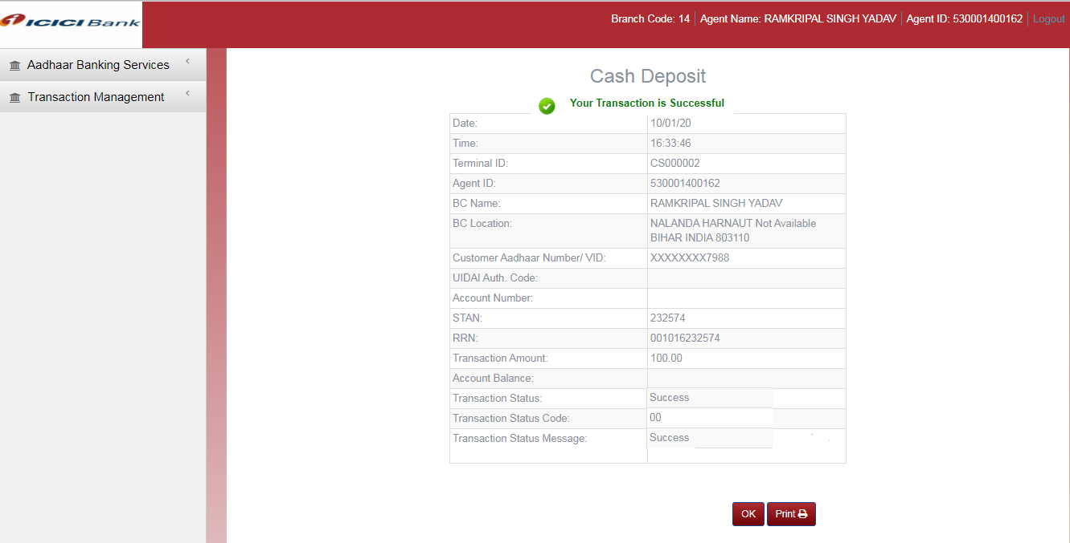

Figure 10: Deposit transaction details

**Field Description**

* All (*) marked fields are mandatory

| Field Name | Field Type | Description |
| --- | --- | --- |
| Date & Time | [Display] | This field displays the local date and time of the transaction. |
| Terminal ID | [Display] | This field displays the terminal ID of the operator. |
| Agent ID | [Display] | This field displays the Agent ID of the Kiosk operator. |
| BC Name | [Display] | This field displays the name of the BC. |
| BC Location | [Display] | This field displays the address location of the BC. |
| Customer Aadhaar Number/VID | [Display] | This field displays the Customer Aadhaar Number for that transaction |
| UIDAI Auth. Code | [Display] | This field displays the UIDAI authorization Code. |
| Account Number | [Display] | This field displays account number of the customer |
| STAN | [Display] | The field displays the System Trace Audit Number |
| RRN | [Display] | This field displays the unique Transaction RRN. |
| Transaction Amount | [Display] | This field displays the transaction amount. |
| Account Balance | [Display] | This field displays the account balance of the customer. |
| Transaction Status | [Display] | This field displays the status i.e. Success / Failure of a transaction. |
| Transaction Status Code | [Display] | This field displays the code of the transaction status message. |
| Transaction Status Message | [Display] | This field displays the transaction status message. |

1. Click on the **Print** button to print the transaction receipt.

OR

Click on the **OK** button to leave this page. The system will navigate to the home screen of the Banking application.

NOTE: The transaction details of the transaction can be viewed again through the Transaction History feature. Please refer Transaction History section of this document.

* 1. Cash Withdrawal

This option allows the Agent user to perform cash withdrawal banking transaction for a customer.

**To do a Cash Withdrawal transaction**

1. Log on to the Banking Application as Agent user.
2. Navigate through the menus to **Aadhaar Banking Services -> Withdrawal**. The system displays Cash Withdrawal screen.

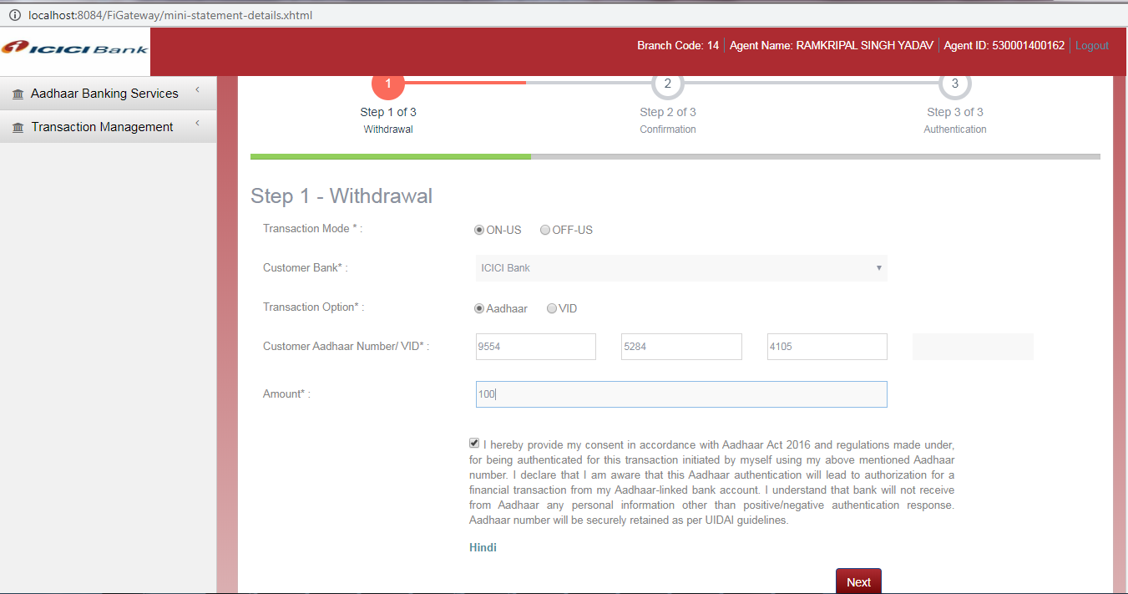

Figure 11: Step-1 Cash Withdrawal screen

**Field Description**

* All (*) marked fields are mandatory

| Field Name | Field Type | | Description |
| --- | --- | --- | --- |
| Transaction Mode | | [Radio Button] | Select the nature of transaction. Select OFF-US, in case the customer or the beneficiary wants operation in bank other than the registered bank, else select ON-US. |
| Customer Bank | [Drop Down] | | Select the bank in case the Transaction Mode is OFF-US. |
| Customer Aadhaar Number /VID (*) | **Aadhaar**: [Numeric, Min. Length - 12]  **VID**: Numeric, Min. Length - 16] | | Enter the Aadhaar Number of the customer. This number must have 12 digits.  In case of VID This number must have 16 digits. |
| Amount (*) | [Numeric] | | Enter the amount of the transaction. Data in this field accepts .50 and .00 in decimal places |
| Next | [Button, Enabled] | | Click this button to move to the next step of the transaction. |

1. Enter all the mandatory transaction data. Click on **Next** button. The system displays the Step-2 screen of the deposit transaction.

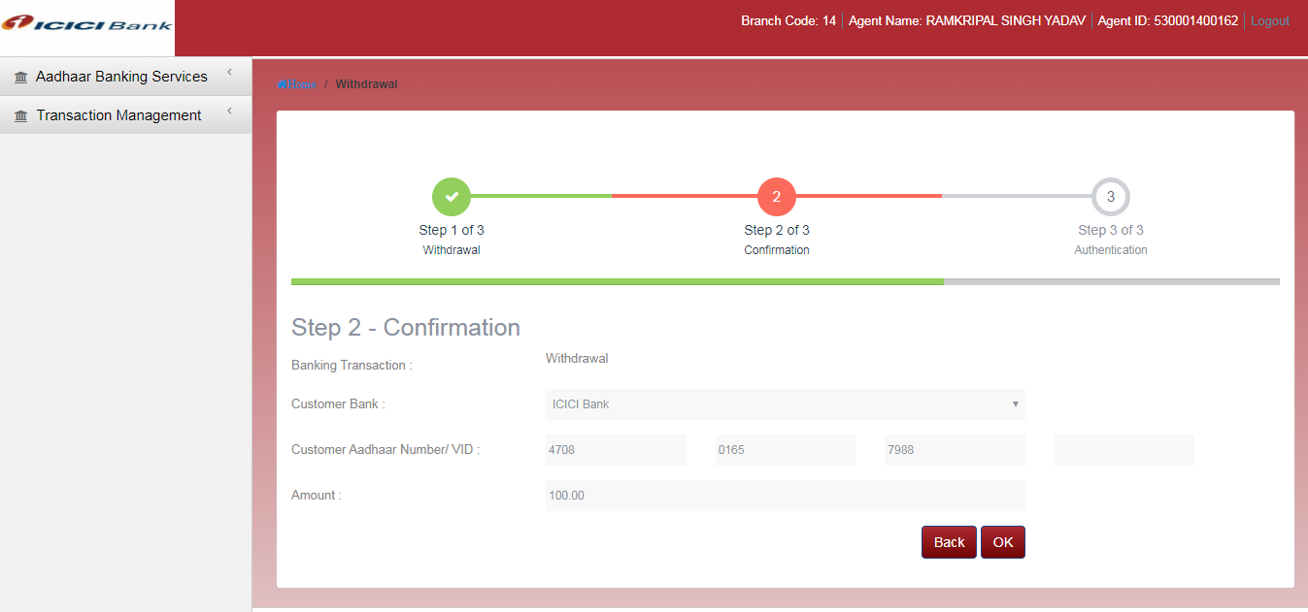

Figure 12: Step-2 Withdrawal transaction screen

**Field Description**

* All (*) marked fields are mandatory

| Field Name | Field Type | Description |
| --- | --- | --- |
| Banking Transaction | [Display] | This field displays the type of Banking Transaction |
| Customer Bank | [Display] | This field displays the name of the Customer Bank. |
| Customer Aadhaar Number/VID | [Display] | This field displays the Aadhaar Number/VID of the customer as entered in the Step-1. |
| Amount | [Display] | This field displays the amount of the transaction as entered in the Step-1. |

1. On the confirmation screen, verify that the transaction data is correct, as per transaction requirement.
2. Click on **OK** button to move to the next step of the transaction. The system displays the Step-3 screen of withdrawal transaction.

OR

To edit the data, click on **Back** button to move to the previous step of the transaction.

**Field Description**

* All (*) marked fields are mandatory

| Field Name | Field Type | Description |
| --- | --- | --- |
| Customer Aadhaar Number/VID | [Display] | This field displays the Aadhaar Number/VID of the customer as entered in the Step-1. |
| Hand | [Radio Button] | Select the hand of the customer, for which the biometric shall be provided. |
| Finger Position | [Radio Button] | Select the finger position of the customer, for which the biometric shall be provided. |
| Finger Biometric | [Picture] | Picture of the biometric scan. |

1. Place customer’s selected finger on the biometric device. Click on the **Start** button to begin biometric scan process. Image of the scan will appear in the finger Biometric area.

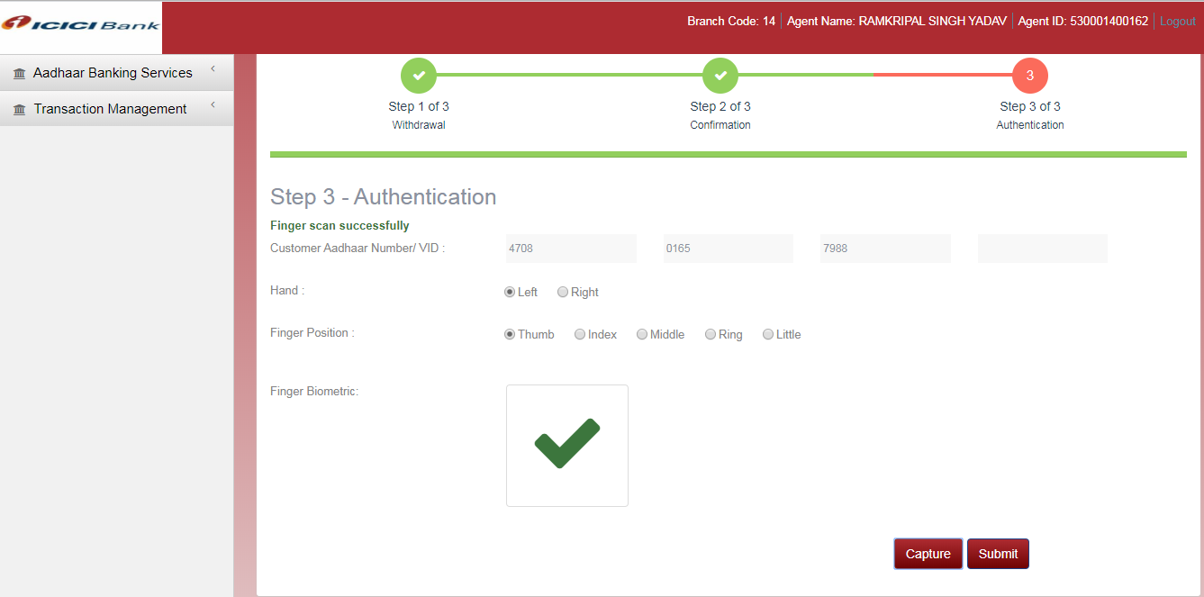

Figure 13: Biometric scan on the Authentication screen

1. Click on the **Submit** button. The transaction is complete. The system will display the transaction status message and a Transaction slip will be generated.

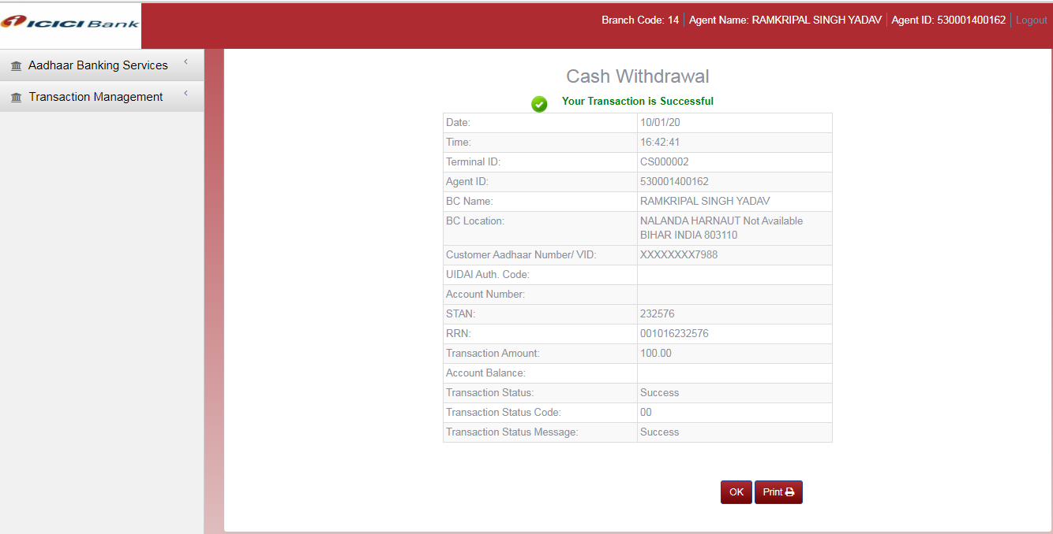

Figure 14: Withdrawal transaction details

**Field Description**

* All (*) marked fields are mandatory

| Field Name | Field Type | Description |
| --- | --- | --- |
| Date & Time | [Display] | This field displays the local date and time of the transaction. |
| Terminal ID | [Display] | This field displays the terminal ID of the operator. |
| Agent ID | [Display] | This field displays the Agent ID of the Kiosk operator. |
| BC Name | [Display] | This field displays the name of the BC. |
| BC Location | [Display] | This field displays the address location of the BC. |
| Customer Aadhaar Number/VID | [Display] | This field displays the Customer Aadhaar Number/VID for that transaction |
| UIDAI Auth. Code | [Display] | This field displays the UIDAI authorization Code. |
| Transaction Type | [Display] | This field displays the type of Transaction i.e. Deposit |
| Account Number | [Display] | This field display the account number of customer |
| STAN | [Display] | The field displays the System Trace Audit Number |
| RRN | [Display] | This field displays the unique Transaction RRN. |
| Transaction Amount | [Display] | This field displays the transaction amount. |
| Account Balance | [Display] | This field displays the account balance of the customer. |
| Transaction Status | [Display] | This field displays the status i.e. Success / Failure of a transaction. |
| Transaction Status Code | [Display] | This field displays the code of the transaction status message. |
| Transaction Status Message | [Display] | This field displays the transaction status message. |

1. Click on the **Print** button to print the transaction receipt.

OR

Click on the **OK** button to leave this page. The system will navigate to the home screen of the Banking application.

**NOTE**: The transaction details of the transaction can be viewed again through the Transaction History feature. Please refer Transaction History section of this document.

* 1. Mini Statement

This option allows the Agent user to get Mini Statement for an account of customer.

**To get a Mini Statement**

1. Log on to the Banking Application as Agent user.
2. Navigate through the menus to **Aadhaar Banking Services -> Mini Statement**. The system displays Mini Statement screen.

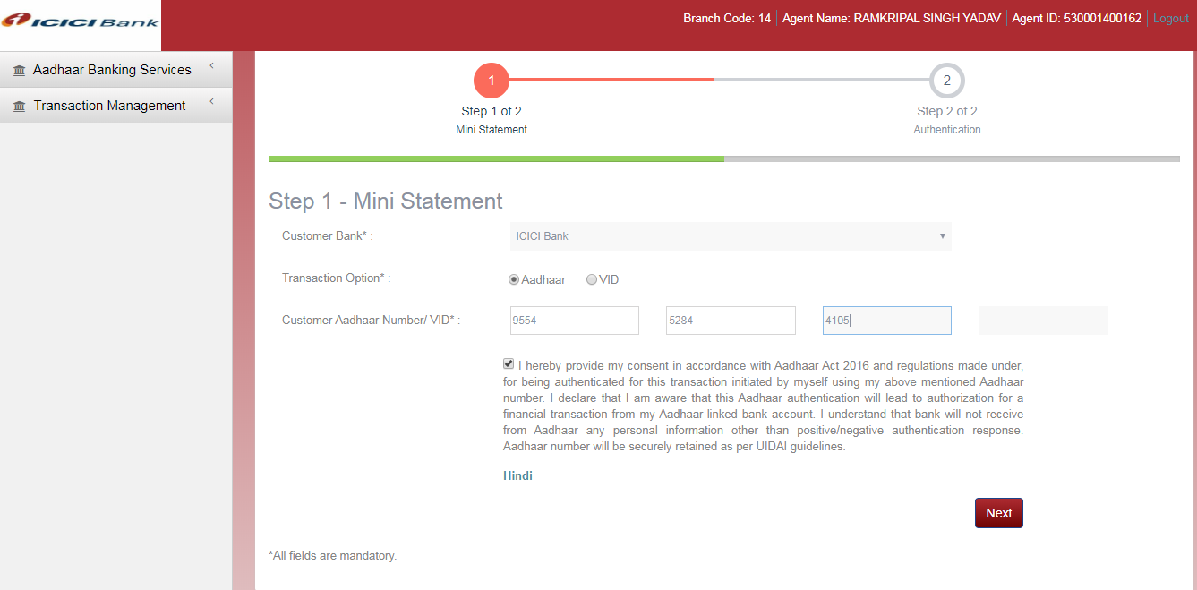

Figure 15: Step-1 Fund Transfer screen

**Field Description**

* All (*) marked fields are mandatory

| Field Name | Field Type | Description |
| --- | --- | --- |
| Customer Bank | [Display] | Select the Customer Bank. |
| Transaction Option | Radio Button | Select the option to provide aadhaar or VID |
| Customer Aadhaar Number /VID (*) | **Aadhaar**: [Numeric, Min. Length - 12]  **VID**: Numeric, Min. Length - 16] | Enter the Aadhaar Number of the customer. This number must have 12 digits.  In case of VID This number must have 16 digits. |
| Next | [Button, Enabled] | Click this button to move to the next step of the transaction. |

1. Enter all the mandatory data. Click on **Next** button. The system displays the Step-2 screen of the deposit transaction.

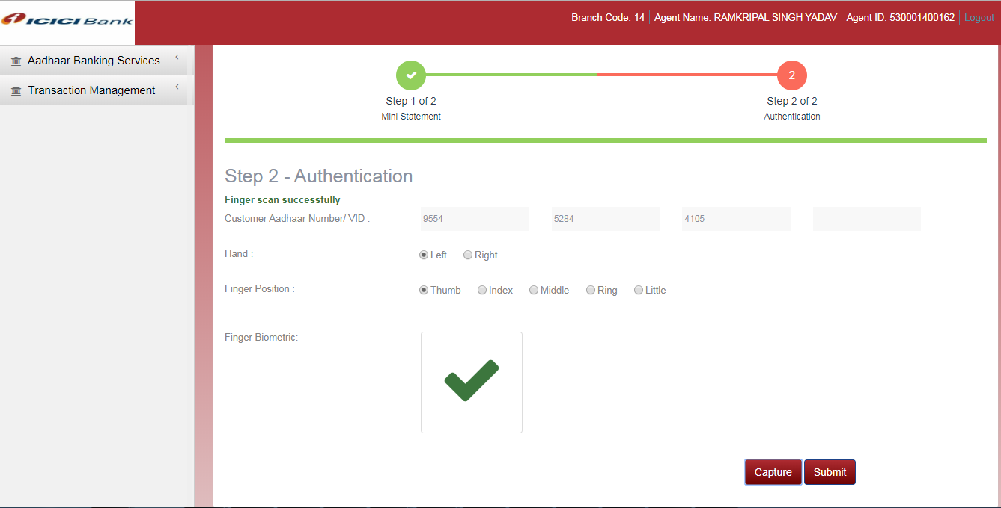

Figure 16: Step-2 Mini Statement Authentication screen

**Field Description**

* All (*) marked fields are mandatory

| Field Name | Field Type | Description |
| --- | --- | --- |
| Customer Aadhaar Number/VID | [Display] | This field displays the Aadhaar Number/VID of the customer as entered in the Step-1. |
| Hand | [Radio Button] | Select the hand of the customer, for which the biometric shall be provided. |
| Finger Position | [Radio Button] | Select the finger position of the customer, for which the biometric shall be provided. |
| Finger Biometric | [Picture] | Picture of the biometric scan. |

1. Place customer’s selected finger on the biometric device. Click on the **Start** button to begin biometric scan process. Image of the scan will appear in the finger Biometric area.
2. Click on the **Submit** button. The transaction is complete. The system will display the transaction status message and a Transaction slip will be generated. There is no data present under this account hence the statement consists of blank description.

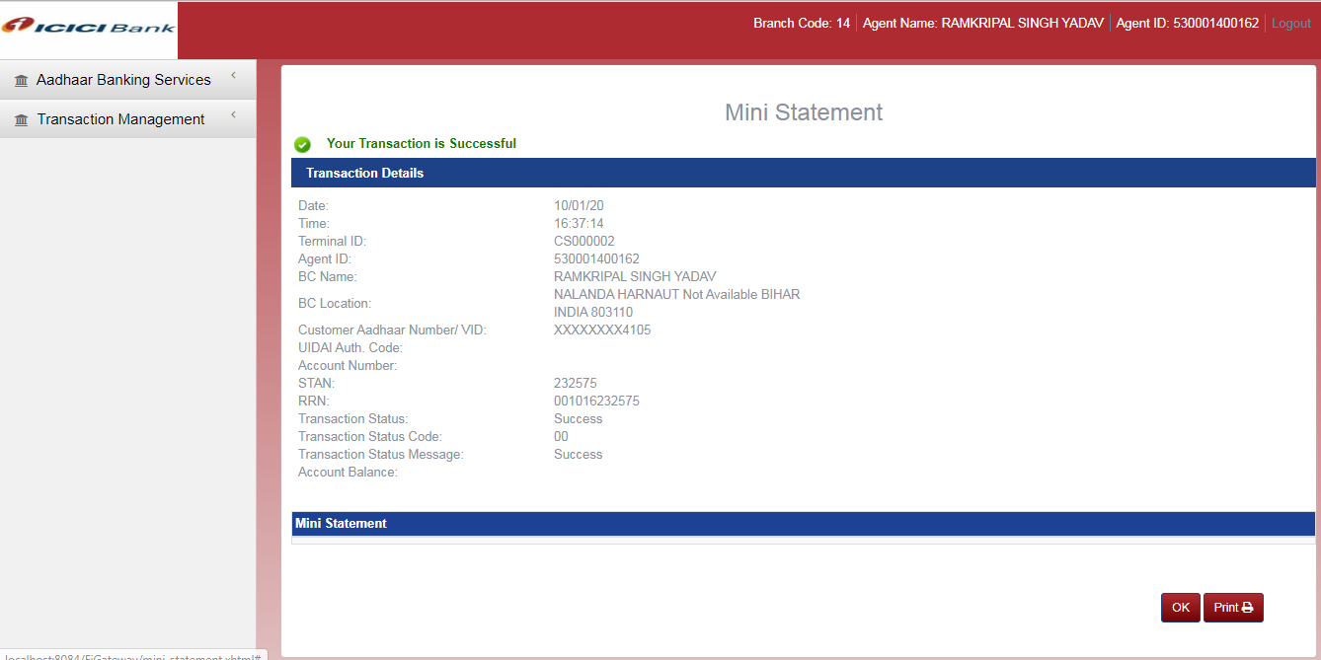

Figure 17: Mini Statement details

**Field Description**

* All (*) marked fields are mandatory

| Field Name | Field Type | Description |
| --- | --- | --- |
| Date & Time | [Display] | This field displays the local date and time of the transaction. |
| Terminal ID | [Display] | This field displays the terminal ID of the operator. |
| Agent ID | [Display] | This field displays the Agent ID of the Kiosk operator. |
| BC Name | [Display] | This field displays the name of the BC. |
| BC Location | [Display] | This field displays the address location of the BC. |
| Customer Aadhaar Number/VID | [Display] | This field displays the Customer Aadhaar Number/VID for that transaction |
| UIDAI Auth. Code | [Display] | This field displays the UIDAI authorization Code. |
| Account Number | [Display] | Account Number of customer |
| STAN | [Display] | The field displays the System Trace Audit Number |
| RRN | [Display] | This field displays the unique Transaction RRN. |
| Transaction Amount | [Display] | This field displays the transaction amount. |
| Transaction Status | [Display] | This field displays the status i.e. Success / Failure of a transaction. |
| Transaction Status Code | [Display] | This field displays the code of the transaction status message. |
| Transaction Status Message | [Display] | This field displays the transaction status message. |
| Account Balance | [Display] | This field displays the account balance of the customer. |
| Mini Statement | [Display] | The Last 5 transaction will be displayed and Last transaction consist of current account balance |

1. Click on the **Print** button to print the transaction receipt.

OR

Click on the **OK** button to leave this page. The system will navigate to the home screen of the Banking application.

NOTE: The transaction details of the transaction can be viewed again through the Transaction History feature. Please refer Transaction History section of this document.

* 1. Balance Inquiry

This option allows the Agent user to perform Balance Inquiry banking transaction for a customer of the bank.

**To do a Balance Inquiry transaction**

1. Log on to the Banking Application as Agent user.
2. Navigate through the menus to **Aadhaar Banking Services -> Balance Inquiry**. The system displays Balance Inquiry screen.

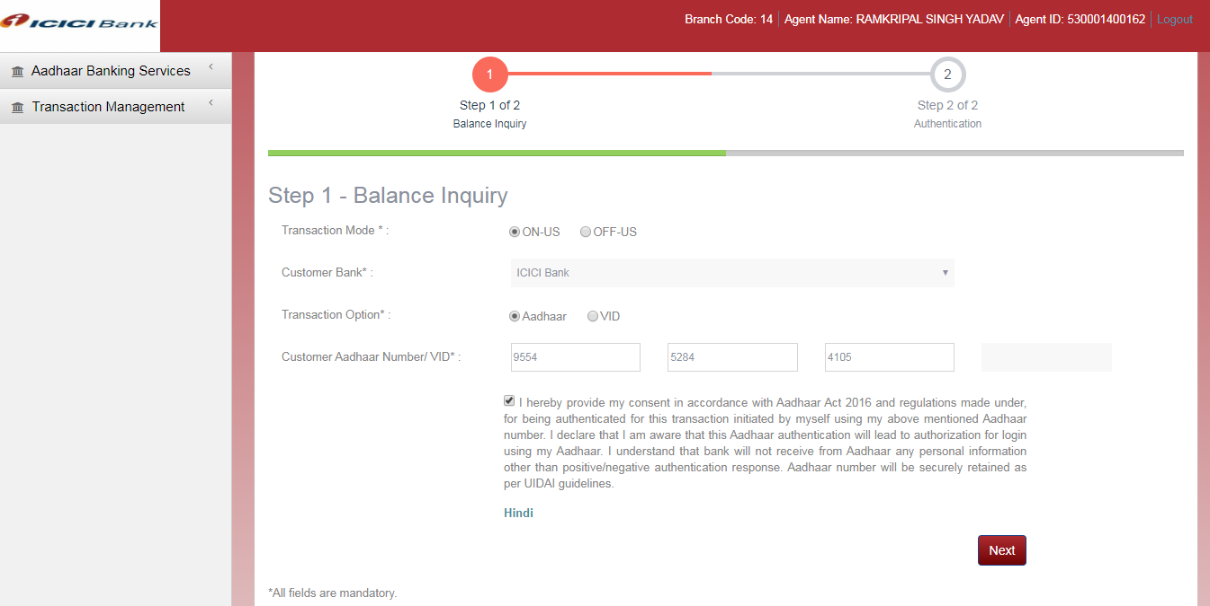

Figure 18: Step-1 Balance Inquiry screen

**Field Description**

* All (*) marked fields are mandatory

| Field Name | | Field Type | | Description |
| --- | --- | --- | --- | --- |
| Transaction Mode | [Radio Button] | | Select the nature of transaction. Select OFF-US, in case the customer or the beneficiary wants operation in bank other than the registered bank, else select ON-US. | |
| Customer Bank | | [Drop Down] | | Select the name of the Customer Bank. |
| Customer Aadhaar Number (*) | | [Numeric, Min. Length - 12] | | Enter the Aadhaar Number of the customer. This number must have 12 digits. |
| Next | | [Button, Enabled] | | Click this button to move to the next step of the transaction. |

1. Enter all the mandatory transaction data. Click on **Next** button. The system displays the Step-2 screen of the Balance Inquiry transaction.

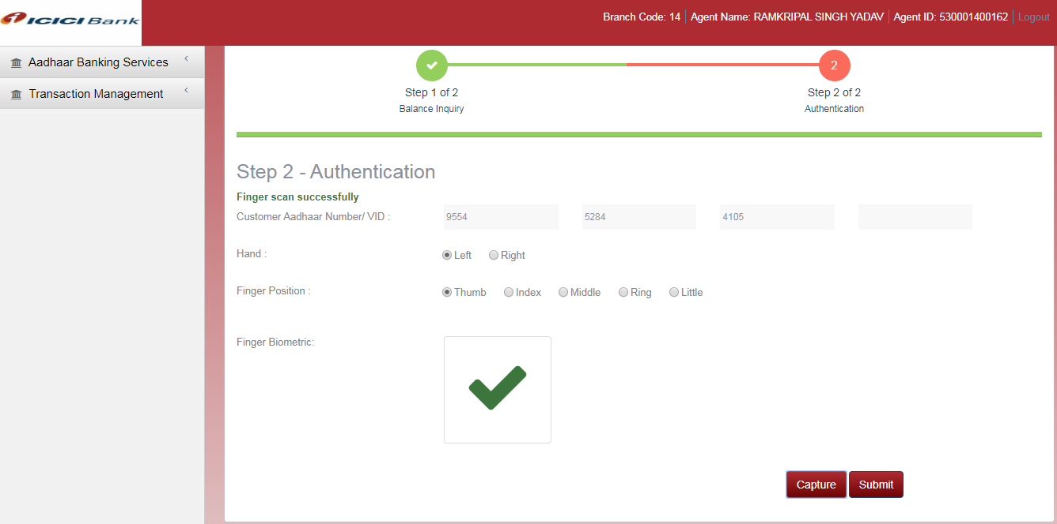

Figure 19: Step-2 Balance Inquiry transaction screen

**Field Description**

* All (*) marked fields are mandatory

| Field Name | Field Type | Description |
| --- | --- | --- |
| Customer Aadhaar Number/VID | [Display] | This field displays the Aadhaar Number/VID of the customer as entered in the Step-1. |
| Hand | [Radio Button] | Select the hand of the customer, for which the biometric shall be provided. |
| Finger Position | [Radio Button] | Select the finger position of the customer, for which the biometric shall be provided. |
| Finger Biometric | [Picture] | Picture of the biometric scan. |

1. Place customer’s selected finger on the biometric device. Click on the **Start** button to begin biometric scan process. Image of the scan will appear in the finger Biometric area.
2. Click on the **Submit** button. The transaction is complete. The system will display the transaction status message and a Transaction slip will be generated.

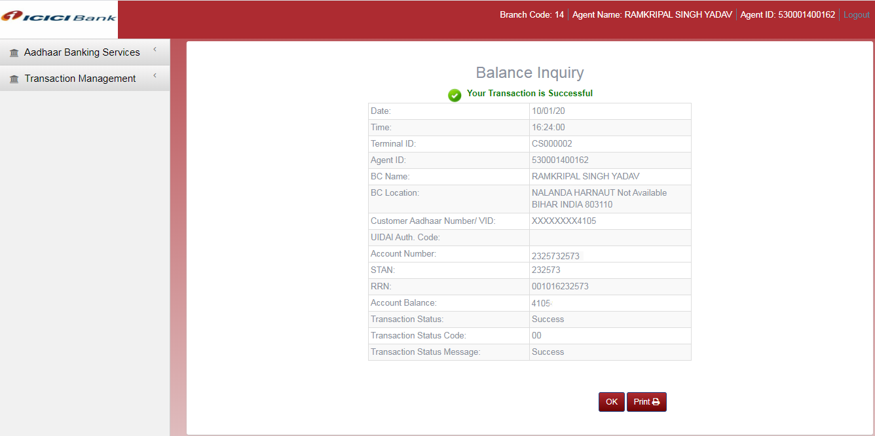

Figure 20: Balance Inquiry Transaction details

**Field Description**

* All (*) marked fields are mandatory

| Field Name | Field Type | Description |
| --- | --- | --- |
| Date & Time | [Display] | This field displays the local date and time of the transaction. |
| Terminal ID | [Display] | This field displays the terminal ID of the operator. |
| Agent ID | [Display] | This field displays the Agent ID of the Kiosk operator. |
| BC Name | [Display] | This field displays the name of the BC. |
| BC Location | [Display] | This field displays the address location of the BC. |
| Customer Aadhaar Number/VID | [Display] | This field displays the Customer Aadhaar Number/VID for that transaction |
| UIDAI Auth. Code | [Display] | This field displays the UIDAI authorization Code. |
| Account Number | [Display] | This field displays Account number of the customer |
| STAN | [Display] | The field displays the System Trace Audit Number |
| RRN | [Display] | This field displays the unique Transaction RRN. |
| Transaction Amount | [Display] | This field displays the transaction amount. |
| Account Balance | [Display] | This field displays the account balance of the customer. |
| Transaction Status | [Display] | This field displays the status i.e. Success / Failure of a transaction. |
| Transaction Status Code | [Display] | This field displays the code of the transaction status message. |

1. Click on the **Print** button to print the transaction receipt.

OR

Click on the **OK** button to leave this page. The system will navigate to the home screen of the Banking application.

NOTE: The transaction details of the transaction can be viewed again through the Transaction History feature. Please refer Transaction History section of this document.

1. Transaction History

This feature allows the Admin, BC, Sub-BC, Agent users to view all the banking transactions initiated by them and by any users under their hierarchy.

Along with the current status, all the transaction details are displayed for every transaction. By default, all transactions of the present date will be visible.

**To view Transaction History**

1. Log on to the Application FI Gateway.
2. Click on the menus item **Transaction Management ->Transaction History**. The system displays the Transaction History screen.

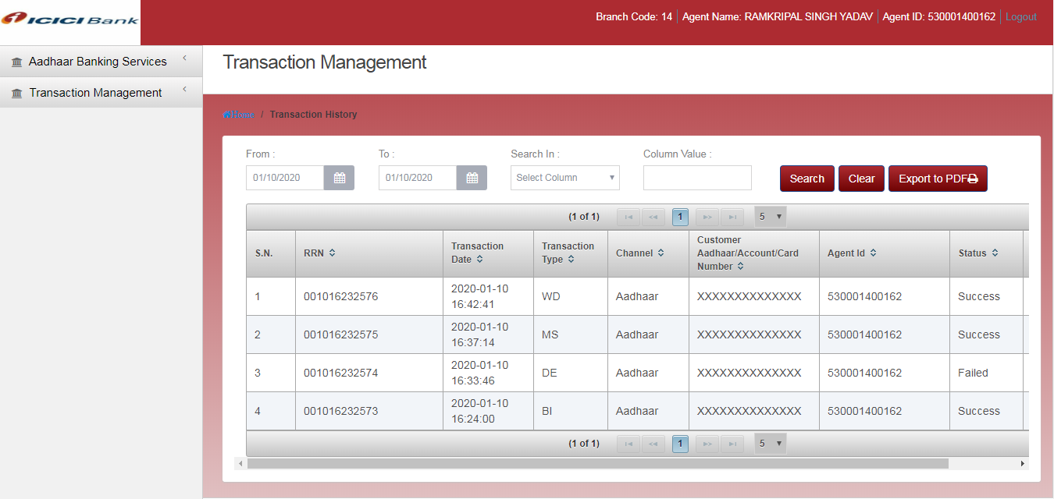

Figure 21: Transaction History screen

**Field Description**

* All (*) marked fields are mandatory

| Field Name | Field Type | Description |
| --- | --- | --- |
| Transactions List - |  |  |
| RRN | [Display] | This column displays the list of RRN |
| Transaction Date | [Display] | The column displays the date of the transaction. |
| Transaction Type | [Display] | This column displays the type of transaction (BI, WD, DE, MS) |
| Customer Aadhaar / Account Number | [Display] | This column displays the Customer Aadhaar Number / Account Number for that transaction |
| Agent ID | [Display] | This column displays the Agent ID of the operator for the transaction. |
| Amount | [Display] | This column displays the transaction amount. |
| Status | [Display] | This column displays the current status of the transaction. |
| Details | [Link] | Provides a link to view full details of the transaction. |
| Search / Filter By- |  |  |
| From Date, To Date | [Date, Pick-list] | Enter Transaction date range |
| Search In | [Drop-down] | Select the search column from the down menu. |
| Column Value | [Alphanumeric, Max. Length - 10] | Type the search string |

1. (Optional) Enter the search criteria and click on the **Search** button on the screen. The searched transactions will be listed in the list.
2. From among the list, in the details column, click on the **View Details** button to get the all the details of the transaction.
3. Appendix
   1. Important terms used in the document

|  |  |
| --- | --- |
| **Aadhaar** | A 12 digit unique number that serves as proof of Identity and Address (for every Indian individual including children and infants), anywhere in India. Randomly generated number issued in public interest by UIDAI. |
| **AEPS** | Aadhaar Enabled Payment Services, offered by NPCI to banks and financial institutions based on Aadhaar. |
| **Bank** | The Bank that is connected with CSC, in which all the banking transactions are executed. |
| **BC / SPV** | Business Correspondent / Special Purpose Vehicles. Organizations that on behalf of the bank become a medium to perform banking transactions. |
| **BFD** | Best Finger Detection |
| **BI** | Balance Inquiry banking transaction |
| **CSC** | Common Service Center. CSC offers web-enabled e-governance services in rural areas, including application forms, certificates, and utility payments such as electricity, telephone and water bills. |
| **DE** | Deposit banking transaction |
| **eKYC** | Electronically know your customer. |
| **FT** | Fund Transfer banking transaction |
| **IIN** | Issuer Identification Number. This number identifies the bank to which the customer has mapped his/her Aadhaar number. |
| **KO / VLE** | Kiosk Operator / Village Level Entrepreneur. Owner of CSC outlet and provides various government and non-government services to the end user. |
| **MS** | Mini-Statement banking transaction |
| **OFF-US** | Banking transaction where customer or beneficiary account is other than the registered bank. |
| **ON-US** | Banking transaction where customer account is of the registered bank. |
| **Sub-BC / SCA** | Sub-Business Correspondents / Service Centre Agencies may be private organizations, who on behalf of CSC become a medium for performing banking transactions |
| **Sub-KO** | Sub-Kiosk Operator. User created by KO, having same role and KO code as KO. |
| **UIDAI** | Unique Identification Authority of  India (UIDAI) |
| **WD** | Withdrawal banking transaction |

* 1. Biometric Device setup

Morpho device has to be used as hardware to capture finger biometric data.

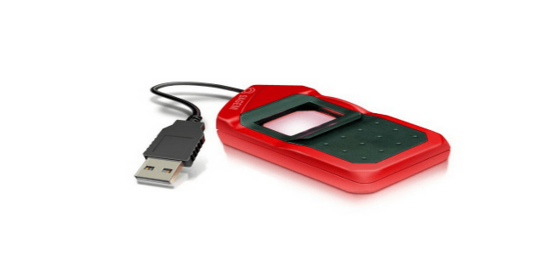

Figure 23: Morpho Biometric device

Steps to setup the biometric device

* 1. Install the driver for the device mfs100-sdk on your machine.
  2. Edit the java policy in the system. Replace the ‘java.policy’ file in your system’s C:\Program Files (x86)\Java\jre1.8.0_25\lib\security’ folder with the file found with the mfs100 driver.
  3. Restart the browser. The biometric device setup is complete. Connect the biometric device to your system via USB, and the device will be ready to use.
  4. Best practices for finger scanning

1. In case the fingers are excessively dry, wipe with wet cloth.
2. In case the fingers are excessively wet, wipe and dry.
3. In case the fingers are not clean (dust/oil/grease), the operator can request the customer to clean the fingers.
4. Operator/Customer needs to clearly know which finger to capture.
   1. Troubleshooting

Some of the probable issues and resolutions are mentioned below. For all other issues please contact your system/network administrator.

**Issue 1:** ‘User not authorized’ error while logging into FI Gateway

**Resolution:** Incorrect biometric is entered.

OR

This User ID is not authorized. Please report to the BC user and request to authorize the user in the system.

**Issue 2:** ‘User does not exist’ error while logging into FI Gateway.

**Resolution:** This User ID is incorrect

**Issue 3:** ‘User is not active’ error while logging into FI Gateway.

**Resolution:** This User ID is inactive. Please report to the BC user for activating the user in the system.

**Issue 4:** ‘User is expired’ error while logging into FI Gateway.

**Resolution:** This User ID is expired. Please report to the BC user for checking the validity of the user in the system.