**CSC e-Governance Services India Ltd**

***Reference Order: No.40-3/2020-DM-I (A ), Ministry of Home Affairs, Govt. of India dated 30/09/2020***

**Coronavirus Disease 2019 (COVID-19): Standard Operating Procedure (SOP) Version 2.0 for “Govt. Approved Common Service Centres (CSCs) at Gram Panchayat level” or as specifically approved by State/UT/District Administration**

1. **About this SOP** This SOP is applicable to current phase of COVID-19 pandemic in India (local transmission and limited community transmission), wherein as per plan of action, all Govt. Approved Common Service Centres at Village/Gram Panchayat/Block/District Level in all the States/UTs across the country will open , operate and provide services to the citizens.
2. **Introduction** Corona viruses are a large family of viruses, some causing illness in people and others that circulate among animals, including camels, cats and bats. In humans, the transmission of COVID-19 can occur via respiratory droplets directly (through droplets from coughing or sneezing) or indirectly (through contaminated objects or surfaces). The people most at risk of COVID-19 infection are those who are in close contact with a suspect/confirmed COVID-19 patient and those who care for such patients.
3. **Best Practices at CSCs**

* Wearing of face cover is compulsory in all CSCs
* All persons in charge of CSCs shall ensure social distancing as per the guidelines issued by Ministry of Health and Family Welfare
* No CSCS shall allow gathering of 5 or more persons
* Spitting in CSCs & vicinity shall be not allowed
* Smoking inside CSCs is banned
* Eating Gutka, tobacco inside CSCs is banned
* If possible, temperature screening may be done while entering CSCs, and provide sanitizers at convenient places
* Persons over 65 years & children below 5 years should not enter CSCs
* Large gathering at CSCs is not allowed
* Frequent cleaning of common surfaces & mandatory hand washing shall be mandated
* Eating by staff at CSCs should be staggered
* Intensive communication, training to CSCs on good hygiene should be taken up

1. **Mask for customers**

All customers who come to CSCs for availing any service shall be asked to come with mask - these can be home made mask.

1. **Information to district administration and police**

CSCs shall keep the district and police informed before starting operations and follow the instructions issued by them strictly including the timing for operations

1. **Simple ways to prevent the spread of COVID-19 at CSCs**

* Make sure the workplaces are clean and hygienic
* Surfaces (e.g. desks and tables) and objects (e.g. telephones, keyboards) need to be wiped with disinfectant regularly
* Why? Because contamination on surfaces touched by staff and customers is one of the main ways that COVID-19 spreads

1. **Promote regular and thorough hand-washing by staff and customers**

* Put sanitizing hand rub dispensers in prominent places around the workplace. Make sure these dispensers are regularly refilled
* Display posters promoting hand-washing
* Combine this with other communication measures such as offering guidance from occupational health and safety officers, briefings at meetings and information on the local cable/radio to promote hand-washing
* Make sure that staff and customers have access to places where they can wash their hands with soap and water
* Why? Because washing kills the virus on your hands and prevents the spread of COVID19

1. **Promote good respiratory hygiene in the CSCs**

* Display posters promoting respiratory hygiene. Combine this with other communication measures such as offering guidance from occupational health and safety officers, briefing at meetings and information on the local cable/radio etc.
* Ensure that face masks and / or paper tissues are available at CSCs, for those who develop a runny nose or cough at work, along with closed bins for hygienically disposing of them
* Why? Because good respiratory hygiene prevents the spread of COVID-19

1. **Infection Prevention**

**9.1 Standard Precautions**

Standard precautions are based on the principle that all blood, body fluids, secretions, excretions (except sweat), non-intact skin, and mucous membranes may contain transmissible infectious agents. These set of measures are intended to be applied to the care of all citizens who visit CSCs.

**9.2 Precautions include:**

* Hand hygiene

**Hand Hygiene** Hand hygiene is the single most important practice to reduce the transmission of infectious agents in healthcare settings. The term “hand hygiene” includes both hand washing with either soap and water, and use of alcohol-based products (gels, rinses, foams) that do not require the use of water. It is important to ensure the availability of hand rub products at all times in the CSC Centre to ensure hand hygiene compliance.

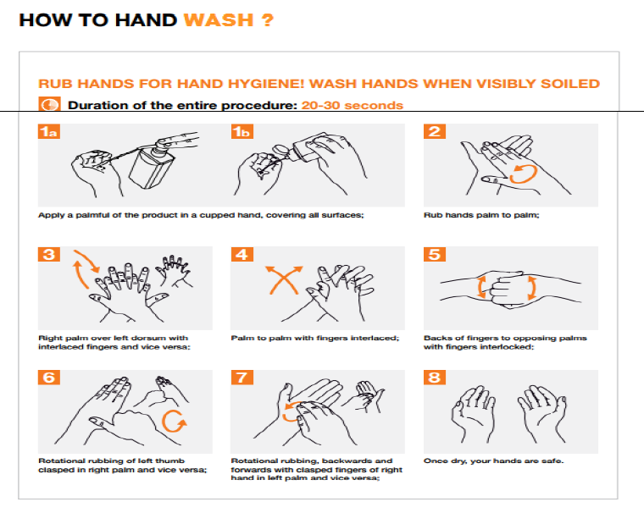

1. **Equipment disinfection:**

Equipment and surfaces are contaminated if they have come in contact with citizen’s skin, blood or body fluids. These can spread infection. Therefore, it is mandatory that these are cleaned and disinfected using 1% sodium hypochlorite or alcohol based disinfectants at least once daily and after every citizen contact. Citizen care items and surfaces that can contribute to the spread of infection include:

* Monitors /Laptops/ Keyboards/biometric device
* mobiles
* Shelves /chairs/sheets
* Glasses/Pen
* Door handles
* Other items and surfaces in office